|  |  |
| --- | --- |
|  | Home phone: __________________________  Cell phone: ____________________________ |



⦁5050 South Florida Ave., Lakeland, FL 33813

⦁1218 Millennium Pkwy., Brandon, FL 33511

⦁217 East Central Ave., Winter Haven, FL 33880

⦁280 Patterson Road, Haines City, FL 33844

MR# _________________

**SPINE INSTITUTE OF CENTRAL FLORIDA  
FIRST VISIT QUESTIONNAIRE**

Please circle answers to questions that pertain to your problem. You may select more than one answer per question. This information will help get an accurate appraisal of your problems, develop an appropriate plan of treatment, and will be included in your visit note. If you have any questions, please ask for assistance.

NAME: ______________________________________________ HEIGHT: ________ WEIGHT: __________

TODAY’S DATE:______________________AGE:____________ SEX: A) Male B) Female

OCCUPATION:________________________________________

ARE YOU: A) Right Handed B) Left Hand C) Ambidextrous

Referred by: Name of Primary Care Physician: ___________________

City, State of your Primary Care Physician: ­   
Is this a second opinion? (A) Yes (B) No

How did you hear about Spine Institute of Central Florida, if not by a referral? ________________

COMPLAINT (What are you being seen for?)

|  |  |  |  |
| --- | --- | --- | --- |
| A.  B.  C. | Neck Pain  Neck Pain with headaches Upper Back Pain | Do you have any: | |
| D.  D. | Right Arm Pain | A. | A. Weakness |
| E. | Left Arm Pain | B. | B. Numbness |
| F. | Lower Back Pain | C. | C. Tingling |
| G. | Right Leg Pain | D. | D. Not Applicable |

H. Left Leg Pain If yes, describe___________________

I. Scoliosis

J. Other: __________________________________

If one or more of the above is chosen, which is the most problematic complaint? _______________________

|  |  |  |  |
| --- | --- | --- | --- |
| What best describes your neck/back pain? | | What best describes your arm/leg/other pain? | |
| A. | Sharp G. Not Applicable | A. | Sharp G. Not applicable |
| B. | Stabbing | B. | Stabbing |
| C. | Burning | C. | Burning |
| D. | Like electricity | D. | Like electricity |
| E. | Dull ache | E. | Dull ache |
| F. | Pins & needles  G. Not applicable | F. | Pins & needles  Not  G. Not applicable |

When did the problem start?

**If problem was caused from an injury, complete this page, otherwise skip to the next page** What is the date of injury?

Was the injury job related? (A) Yes (B) No

If not at work, WHERE did the injury occur?

How did the injury occur? If motor vehicle accident, were you:

|  |  |  |  |
| --- | --- | --- | --- |
| A. | No injury (skip to next page) | A. | Driver |
| B. | Motor vehicle accident - no litigation | B. | Front seat passenger |
| C. | Motor vehicle accident - litigation pending | C. | Rear seat passenger |
| D. | Motor vehicle accident - litigation complete | D. | Motorcycle driver |
| E. | Fall | E. | Motorcycle passenger |
| F. | Sports or recreation | F. | Other______________________ |

G. Job related

H. Other_______________________________ Were you wearing a seat belt? (A) Yes (B) No

Were you (A) Rear-ended (B) T-boned (C) Head-on (D) Other

Other injuries due to this condition/accident: (A) None (B) Yes, explain

If your condition is secondary to an injury, are you still currently working? (A) Yes B) No

If not currently working due to this injury, how long have you been out of work? Approximately since: day ____month year.

Please BRIEFLY explain the circumstances that led to your condition (**Please write a SHORT narrative BELOW (3-5 Sentences). If your condition/symptoms started as a result of a fall, an accident in a car or at work, briefly describe what happened, or how it happened. Likewise make sure to indicate that your symptoms started on its own, if your symptoms started without any known cause.**):

**INTENTIONALLY BLANK**PLEASE PROCEED TO NEXT PAGE

What treatments have you already received **SPECIFICALLY for this condition**?

1. Medications (including prescription and over-the-counter)? (A) Yes (B) No
2. (If yes, list medications)
3. Physical therapy? (A) Yes (B) No (If yes, how many weeks?)
4. Chiropractic care? (A) Yes (B) No (If yes, how many weeks?)
5. Neck/Cervical Spine Epidural injections? (A) Yes (B) No
6. How many injections? When was the last injection? _____/_____/_____
7. Back/Lumbar Spine Epidural injections? (A) Yes (B) No
8. How many injections? When was the last injection? _____/_____/_____
9. Cervical collar or Back brace? (A) Yes (B) No.
10. Other treatments received (please list)

|  |  |  |  |
| --- | --- | --- | --- |
| Since the pain/condition began it: | | What time of the day is pain most intense? (Circle ALL that apply) | |
| A. | Has improved | A. | On first arising in the morning |
| B. | Has worsened |  | During the daytime or while at work |
| C. | Has stayed the same | C. | At the end of the day before bedtime |
| D. | Comes and goes (fluctuates) | D. | During the night |

|  |  |  |  |
| --- | --- | --- | --- |
| What aggravates the pain? (Circle ALL that apply) | | What makes the pain better?  (Circle ALL that apply) | |
| A. | Walking | A. | Sitting |
| B. | Standing |  | Lying down |
| C. | Sitting | C. | Walking |
| D. | Lying down | D. | Standing |
| E. | Activity in general | E. | Nothing in particular |
| F. | Stooping/bending | F. | Other/comments:_______________________ |
| G. | Nothing in particular |
| H. | Other/comments:________________ |

Does the pain awaken you from sleep? Does the pain keep you from sleeping?

1. Never A. Never
2. Occasionally B. Occasionally
3. Frequently C. Frequently

Do you have any difficulty walking? Is the walking difficulty related to this condition?

1. No A. Yes
2. Yes, can walk unlimited distances B. No, explain
3. Yes, can walk less than a mile
4. Yes, can walk only 1-2 blocks
5. Yes, can walk less than 1 block
6. Yes, non-ambulatory (cannot walk)
7. Other
8. Do you use any assistive device(s) for ambulation (e.g. wheelchair, walker, cane, crutches, etc.)?
9. Yes
10. No
11. Not applicable

If yes, which assistive device do you use______________________; for how long__________________

Do you use the assistive device (A) Frequently (B) Occasionally (C) Rarely

Have you had any problems with bowel, bladder, or sexual functions since this condition began?

1. No
2. Yes Please explain

Have you had a previous back or neck problem?

1. No
2. Yes Please explain _______________________________________________

Do you exercise regularly?

1. No
2. Yes How often? _______________________________________________________

**PAST MEDICAL/SURGICAL HISTORY**

Do you have a history of any of these medical conditions?

|  |  |  |  |  |
| --- | --- | --- | --- | --- |
| Diabetes YES | NO | Liver disease | YES | NO |
| _____Diet controlled |  |  |  |  |
| _____Medication controlled |  | Kidney disease | YES | NO |
| _____Insulin controlled |  |  |  |  |
|  |  | Hepatitis | YES | NO |
| High blood pressure YES | NO | Type? _______ |  |  |
| Heart disease YES | NO | Immune disorder | YES | NO |
| ______Chest pain/angina |  |  |  |  |
| _____Heart attack, Date_______ | ______ | Seizures | YES | NO |
| ______Valve disease |  |  |  |  |
|  |  | Eye problems | YES | NO |
| Cancer/Tumor YES | NO |  |  |  |
| What type? |  | Headaches | YES | NO |
| Ulcers YES | NO | Thyroid disorder | YES | NO |
| Lung disease including emphysema |  | Osteoarthritis (wear and tear) | YES | NO |
| YES | NO |  |  |  |
|  |  | Rheumatoid arthritis | YES | NO |
| Stroke YES | NO |  |  |  |
| When? _________ |  | Asthma | YES | NO |
| Circulation problems YES | NO | Mental disorder | YES | NO |
|  |  | Explain___________ |  |  |
| High cholesterol YES | NO |  |  |  |

List Other Medical Problems/History

Have you ever had any neck or back (spine) surgery?

1. No
2. Yes How many?

Please list your previous neck and back (spine) operations.

**Date Place Surgeon Procedure**

Have you ever had any other surgery BESIDES spine (including small procedures like “wisdom teeth extraction”)?

1. No
2. Yes: Please list below

**Date Procedure**

Have you EVER had an infection after any surgery?

1. No
2. Yes Please Describe:

**CURRENT MEDICATIONS**

1. None
2. Yes: Please list below

**Name Dose For what problem?**

**ALLERGIES**

Do you have any Allergies?

1. No known allergies including medications, iodine/contrast dye, latex or shellfish
2. Yes, please list________________________________________________

**SOCIAL AND FAMILY HISTORY**

Marital status: (A) Single (B) Married (C) Divorced (D) Widowed How many children do you have?

What is the highest level of education you have completed?

(A) Some high school (B) High school (C) Trade school (D) College (E) Professional school

Do you smoke? (A) No (B) Yes. How many packs per day?

How many years have you been smoking?

Do you smoke a pipe? (A) No (B) Yes. How often?

Do you smoke cigars? (A) No (B) Yes. How often?

Do you use smokeless tobacco? (A) No (B) Yes. How much?

Did you ever smoke regularly before? (A) No (B) Yes. How many packs per day?

How many years did you smoke? When did you quit smoking?

With regards to your alcohol consumption, would you say you:

(A) drink heavily (B) drink moderately (C) drink occasionally (D) drink only on social events

(E) drink rarely (F) never drink alcohol.

Are you a recovering alcoholic; or did you have a history of heavy alcohol use in the past? (A) Yes (B) No

How much alcohol do you consume in an average week (beer, wine, etc.)?

1. None
2. Less than 6 drinks
3. 6-12 drinks
4. 12-24 drinks
5. 24-48 drinks
6. More than 48 drinks

Have you used any of the following substances in the past year (circle all that applies):

(A) Marijuana (B) Methamphetamines (C) Ecstasy (D) Ketamine

(E) Anabolic Steroids (F) Cocaine (G) Heroin (H) Rohypnol

(I) LSD (J) GHB (K) ***Abuse*** Prescription Drugs [e.g. Oxycontin, Valium, etc]

1. Other addicting drugs
2. None

If you do not currently use any of the drugs above; have you used them in the past **5** years? (A) Yes (B) No. If yes, list the ones you have used in the past **5** years (For example “A and F” for Marijuana and Cocaine).

What is your **current** work status?

1. Regular employment - no restrictions
2. Full time with restrictions
3. Part time by choice
4. Part time with restrictions
5. Part time due to a spine problem
6. Part time due to other medical reason, Specify
7. Retired by choice
8. Retired due to a spine problem
9. Retired due to other medical reason, Specify
10. Unemployed - looking for work with no restrictions
11. Unemployed - looking for light duty work
12. Unemployed
13. Currently not working due to a spine problem
14. Currently not working due to other medical reason, Specify
15. Student (what grade level, or type of training are you undergoing?)

If NOT working, are you on Disability? (A) YES (B) NO

Do you have a **FAMILY HISTORY** of any of these diseases? (Circle all that are appropriate)

1. None
2. Back or neck problems
3. Cancer
4. Diabetes
5. Heart disease
6. Hypertension
7. Osteoarthritis (wear & tear)
8. Rheumatoid arthritis
9. Scoliosis
10. Stroke
11. Other

**INTENTIONALLY BLANK**PLEASE PROCEED TO NEXT PAGE

**REVIEW OF SYSTEMS**

Have you **recently** experienced any of the following?

|  |
| --- |
| General:  Weight gain YES NO  Weight loss YES NO  Fever YES NO  Chills YES NO  Night sweats YES NO  Skin:  Change in moles YES NO  Breast lumps YES NO  Rash or Itching YES NO  Eyes:  Loss of vision YES NO  Double vision YES NO  ENT:  Hearing loss YES NO  Nose bleeds YES NO  Difficulty Swallowing YES NO  Difficulty Speaking YES NO  GI:  Nausea YES NO  Vomiting YES NO  Change in bowel habits YES NO  Heartburn YES NO  Blood in stool YES NO  Stool black in color YES NO  Respiratory:  Shortness of breath YES NO  Coughing/wheezing YES NO  Hematologic:  Bleeding Tendencies YES NO  Bruising Tendencies YES NO  Anemia YES NO |
| Heart:  Chest pain YES NO  Palpitations YES NO  Fainting YES NO  GU:  Frequent urination YES NO  Difficulty with urination YES NO  Blood in urine YES NO  Vascular:  Swelling lower extremities YES NO  Emboli (blood clots) YES NO  Musculoskeletal:  Muscle weakness YES NO  Stiffness YES NO  Joint pain YES NO  Psych:  Anxiety YES NO  Depression YES NO  Confusion YES NO  Memory loss YES NO  Immunologic:  Frequent Infections YES NO  Swollen Glands YES NO  Neurologic:  Dizziness YES NO  Coordination problems YES NO  Frequent Headaches YES NO  **Dr. signature_________________________________** | |

**OFFICE USE ONLY**

(One of the 2 boxes below to be checked off by Physician during your visit)

[ ] Informed patient to notify his/her primary care physician of all the above positive review of systems.

Patient verbally expressed understanding this instruction, and agrees to do so.

[ ] Patient states that his/her Primary Care Physician is aware of all positive review of systems above.

**Patients, please proceed to the next page...**

**SPINE INSTITUTE OF CENTRAL FLORIDA  
PAIN ASSESSMENT FORM**

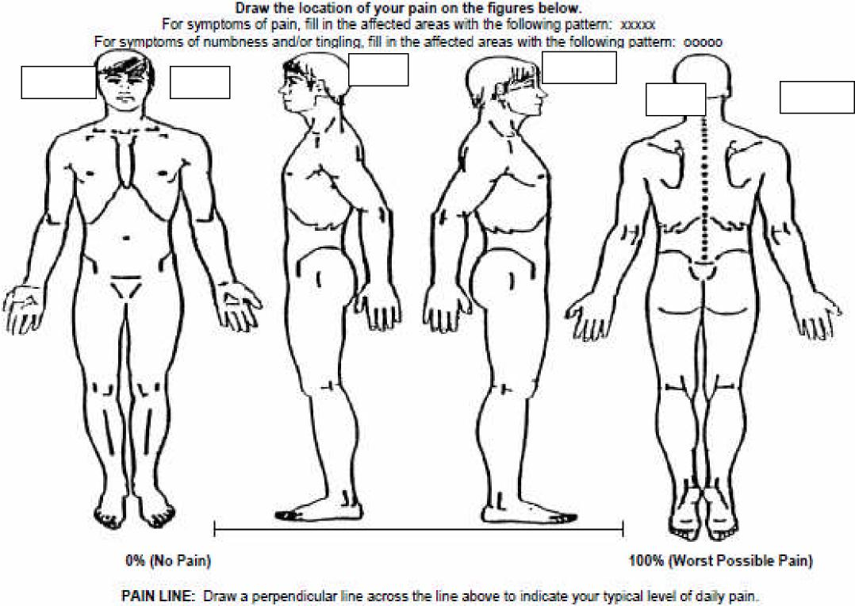

**RIGHT**

**LEFT**

**LEFT**

**RIGHT**

**LEFT**

**RIGHT**

**INTENTIONALLY BLANK**PLEASE PROCEED TO NEXT PAGE

If you are here today for your **back and legs**, of the discomfort you have in your Lower Back and Leg(s) what  
percentage is above your waist (belt-line) and what percentage is below your waist (belt-line) -- both must add  
up to a total of 100%  
(for example 70%/30%; versus 10%/90%; versus 50%/50%; versus 5%/95%; versus 0%/100% etc.)

|  |  |  |
| --- | --- | --- |
|  | **Lower Back (above belt-line)** | **Legs (below belt-line)** |
| **Percentage of discomfort (both MUST total 100%)** | **%** | **%** |

|  |  |  |
| --- | --- | --- |
|  | **Right Leg** | **Left Leg** |
| **Percentage of discomfort (both MUST total 100%)** | **%** | **%** |

If you are here today for your **neck and arms**, of the discomfort you have in your Neck and Arms(s) what  
percentage is in your neck and what percentage is in your arms and upper back -- both must add up to a total  
of 100%  
(for example 70%/30%; versus 10%/90%; versus 50%/50%; versus 5%/95%; versus 0%/100% etc.)

|  |  |  |
| --- | --- | --- |
|  | **Neck** | **Arms and shoulders** |
| **Percentage of discomfort (both MUST total 100%)** | **%** | **%** |

|  |  |  |
| --- | --- | --- |
|  | **Right Arms/Shoulders** | **Left Arms/Shoulders** |
| **Percentage of discomfort (both MUST total 100%)** | **%** | **%** |